|  |  |  |  |  |  |  |  |  |  |
| --- | --- | --- | --- | --- | --- | --- | --- | --- | --- |
| **SCHOOL OF COMPUTER SCIENCE AND ARTIFICIAL INTELLIGENCE** | | | | | **DEPARTMENT OF COMPUTER SCIENCE ENGINEERING** | | | | |
| **Program Name:** B. Tech | | | | **Assignment Type: Lab** | | | **Academic Year:**2025-2026 | | |
| **Course Coordinator Name** | | | | Venkataramana Veeramsetty | | | | | |
| **Instructor(s) Name** | | | | |  | | --- | | Dr. V. Venkataramana (Co-ordinator) | | Dr. T. Sampath Kumar | | Dr. Pramoda Patro | | Dr. Brij Kishor Tiwari | | Dr.J.Ravichander | | Dr. Mohammand Ali Shaik | | Dr. Anirodh Kumar | | Mr. S.Naresh Kumar | | Dr. RAJESH VELPULA | | Mr. Kundhan Kumar | | Ms. Ch.Rajitha | | Mr. M Prakash | | Mr. B.Raju | | Intern 1 (Dharma teja) | | Intern 2 (Sai Prasad) | | Intern 3 (Sowmya) | | NS_2 ( Mounika) | | | | | | |
| **Course Code** | | | 24CS002PC215 | **Course Title** | | AI Assisted Coding | | | |
| **Year/Sem** | | | II/I | **Regulation** | | R24 | | | |
| **Date and Day**  **of Assignment** | | | Week6 - Thursday | **Time(s)** | |  | | | |
| **Duration** | | | 2 Hours | **Applicable to**  **Batches** | |  | | | |
| **AssignmentNumber:11.1**(Present assignment number)/**24**(Total number of assignments) | | | | | | | | | |
|  | **Q.No.** | **Question** | | | | | | ***Expected Time***  ***to complete*** |  |
|  | 1 | **Lab 11 – Data Structures with AI: Implementing Fundamental Structures**  **Lab Objectives**   * Use AI to assist in designing and implementing fundamental data structures in Python. * Learn how to prompt AI for structure creation, optimization, and documentation. * Improve understanding of Lists, Stacks, Queues, Linked Lists, Trees, Graphs, and Hash Tables. * Enhance code quality with AI-generated comments and performance suggestions.   **Task 1: Implementing a Stack (LIFO)**   * **Task**: Use AI to help implement a **Stack** class in Python with the following operations: push(), pop(), peek(), and is_empty(). * **Instructions**:   + Ask AI to generate code skeleton with docstrings.   + Test stack operations using sample data.   + Request AI to suggest optimizations or alternative implementations (e.g., using collections.deque). * **Expected Output**:   + A working Stack class with proper methods, Google-style docstrings, and inline comments for tricky parts.   **Task 3: Singly Linked List with Traversal**   * **Task**: Implement a **Singly Linked List** with operations: insert_at_end(), delete_value(), and traverse(). * **Instructions**:   + Start with a simple class-based implementation (Node, LinkedList).   + Use AI to generate inline comments explaining pointer updates (which are non-trivial).   + Ask AI to suggest test cases to validate all operations. * **Expected Output**:   + A functional linked list implementation with clear comments explaining the logic of insertions and deletions.   **Task 4: Binary Search Tree (BST)**   * **Task**: Implement a **Binary Search Tree** with methods for insert(), search(), and inorder_traversal(). * **Instructions**:   + Provide AI with a partially written Node and BST class.   + Ask AI to complete missing methods and add docstrings.   + Test with a list of integers and compare outputs of search() for present vs absent elements. * **Expected Output**:   + A BST class with clean implementation, meaningful docstrings, and correct traversal output.   **Task 5: Graph Representation and BFS/DFS Traversal**   * **Task**: Implement a **Graph** using an adjacency list, with traversal methods BFS() and DFS(). * **Instructions**:   + Start with an adjacency list dictionary.   + Ask AI to generate BFS and DFS implementations with inline comments.   + Compare recursive vs iterative DFS if suggested by AI. * **Expected Output**:   + A graph implementation with BFS and DFS traversal methods, with AI-generated comments explaining traversal steps.   Top of Form | | | | | | Week6 - Thursday |  |

**Task 1: Implementing a Stack (LIFO)**

* **Task**: Use AI to help implement a **Stack** class in Python with the following operations: push(), pop(), peek(), and is_empty().
* **Instructions**:
  + Ask AI to generate code skeleton with docstrings.
  + Test stack operations using sample data.
  + Request AI to suggest optimizations or alternative implementations (e.g., using collections.deque).
* **Expected Output**:
  + A working Stack class with proper methods, Google-style docstrings, and inline comments for tricky parts.

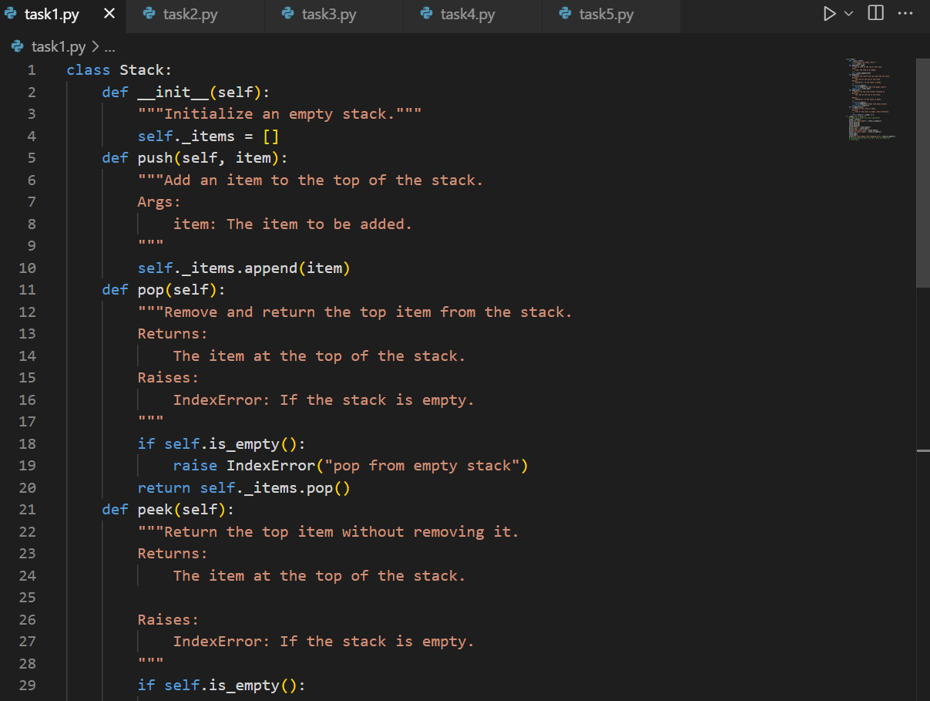

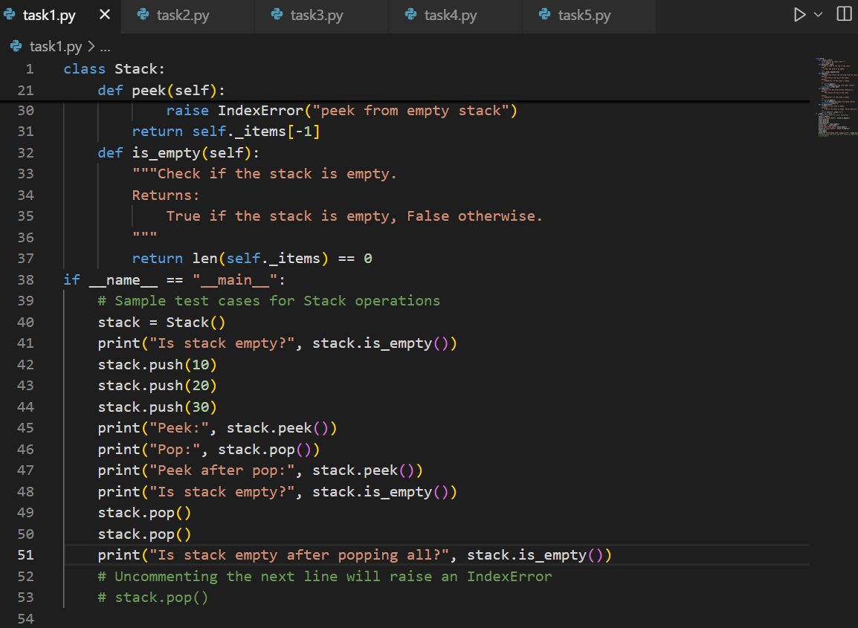

Output:

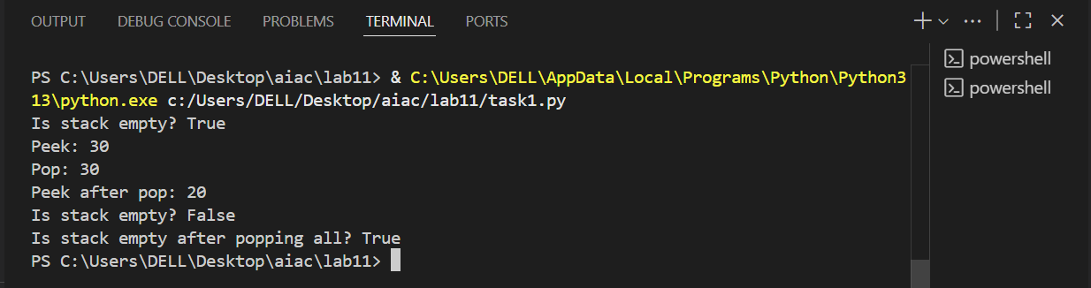

**Task 2: Queue Implementation with Performance Review**

* **Task**: Implement a **Queue** with enqueue(), dequeue(), and is_empty() methods.
* **Instructions**:
  + First, implement using Python lists.
  + Then, ask AI to review performance and suggest a more efficient implementation (using collections.deque).
* **Expected Output**:
  + Two versions of a queue: one with lists and one optimized with deque, plus an AI-generated performance comparison.

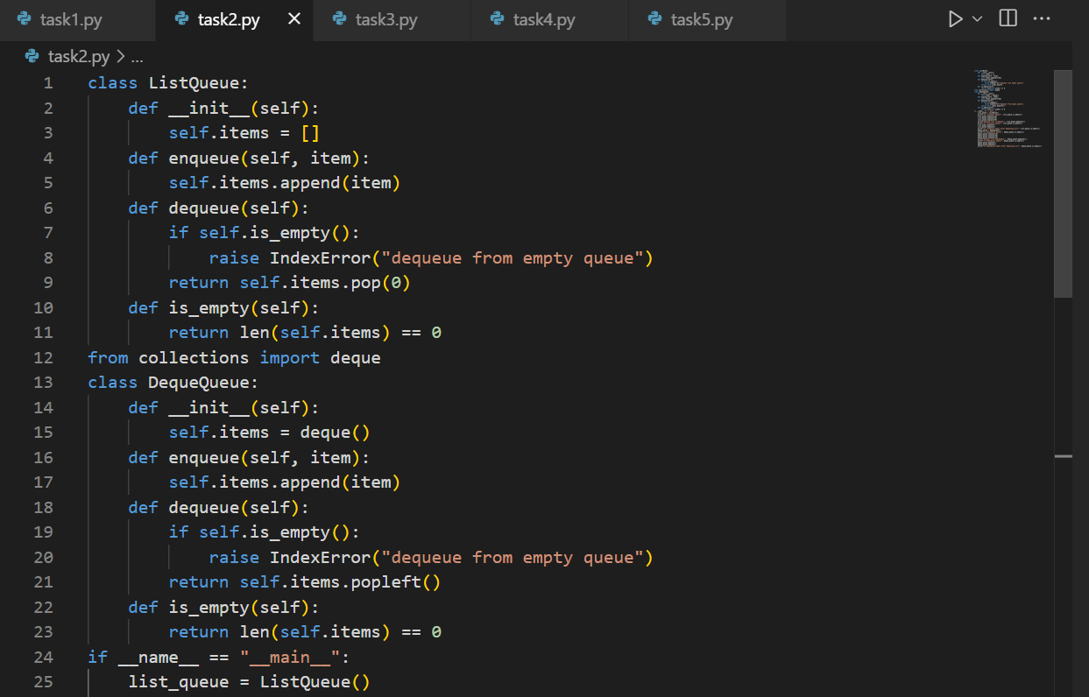

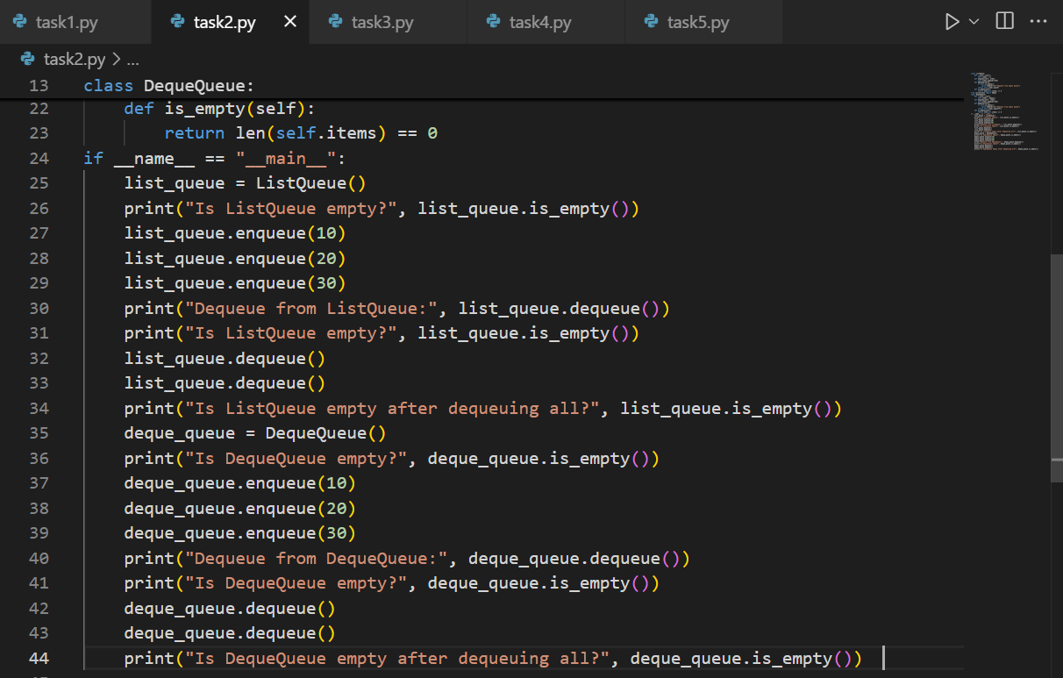

Output:

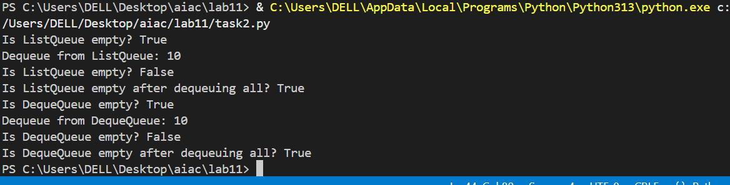

**Task 3: Singly Linked List with Traversal**

* **Task**: Implement a **Singly Linked List** with operations: insert_at_end(), delete_value(), and traverse().
* **Instructions**:
  + Start with a simple class-based implementation (Node, LinkedList).
  + Use AI to generate inline comments explaining pointer updates (which are non-trivial).
  + Ask AI to suggest test cases to validate all operations.
* **Expected Output**:
  + A functional linked list implementation with clear comments explaining the logic of insertions and deletions.

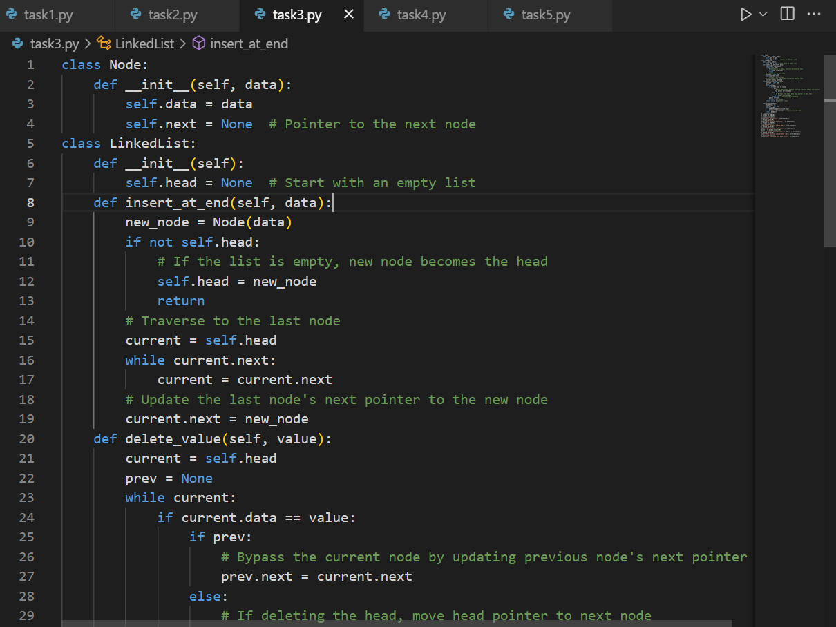

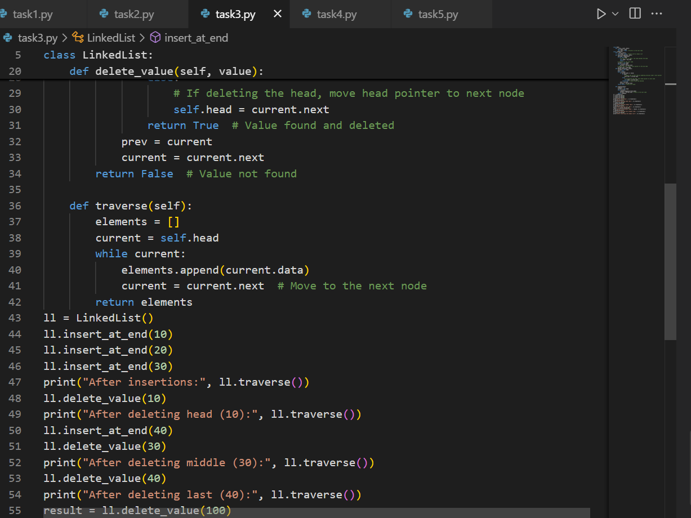

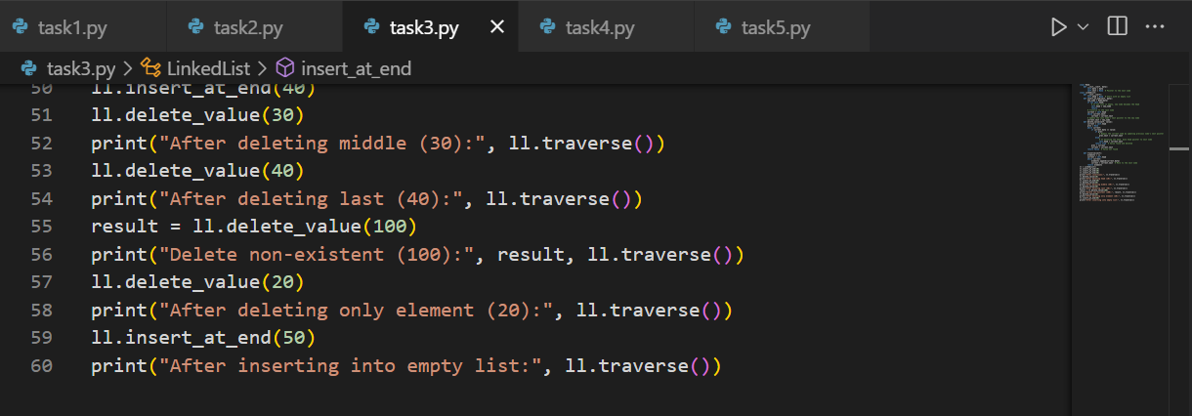

Output:

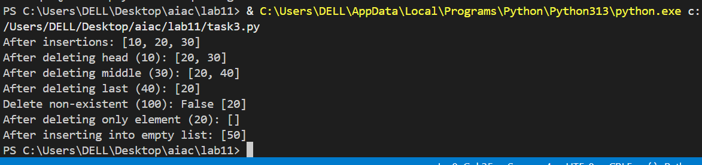

**Task 4: Binary Search Tree (BST)**

* **Task**: Implement a **Binary Search Tree** with methods for insert(), search(), and inorder_traversal().
* **Instructions**:
  + Provide AI with a partially written Node and BST class.
  + Ask AI to complete missing methods and add docstrings.
  + Test with a list of integers and compare outputs of search() for present vs absent elements.
* **Expected Output**:
  + A BST class with clean implementation, meaningful docstrings, and correct traversal output.

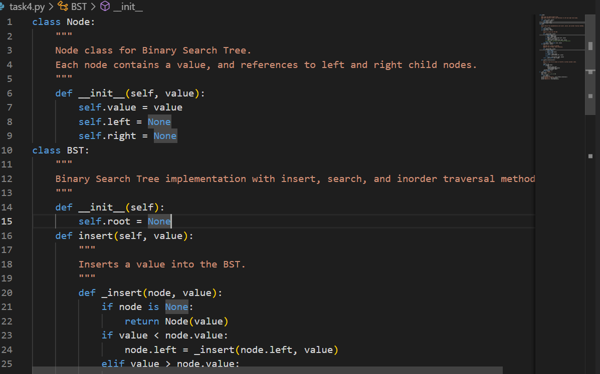

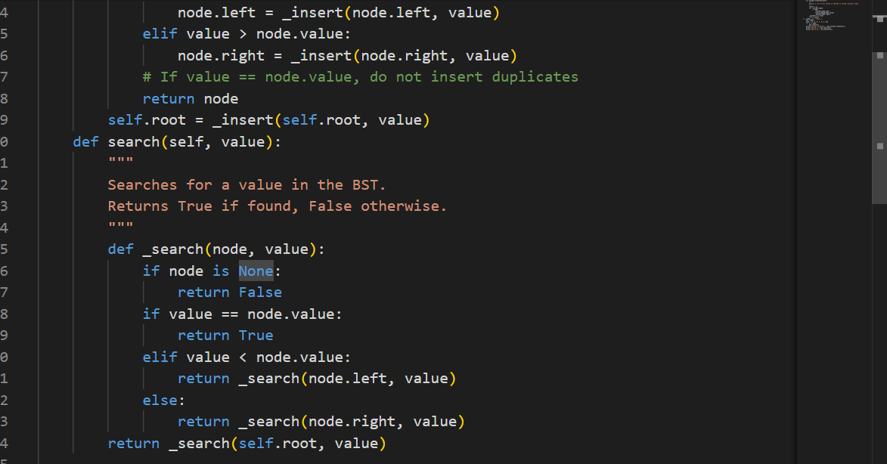

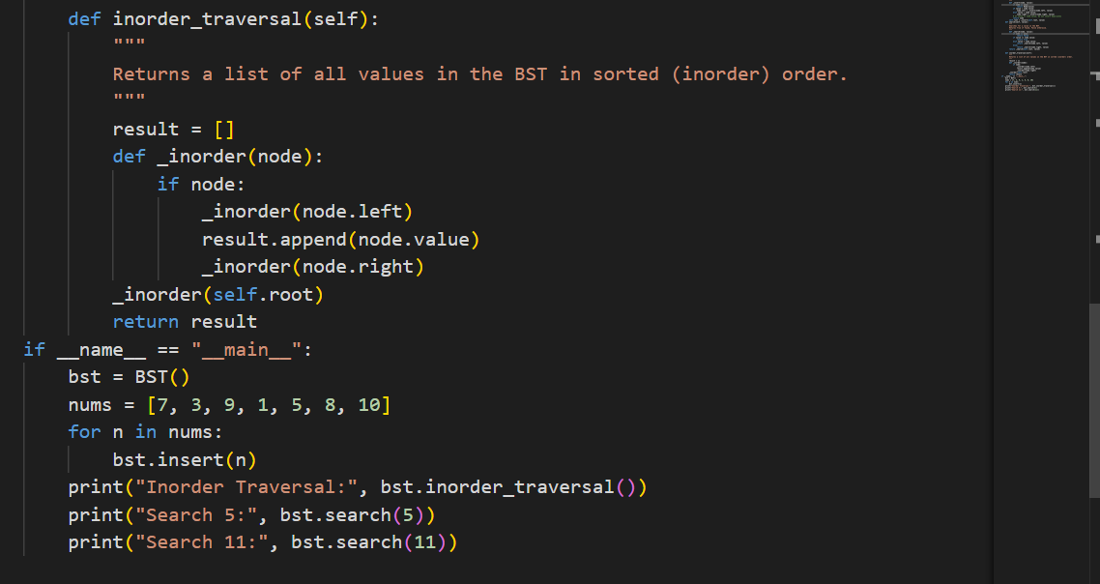

Output:

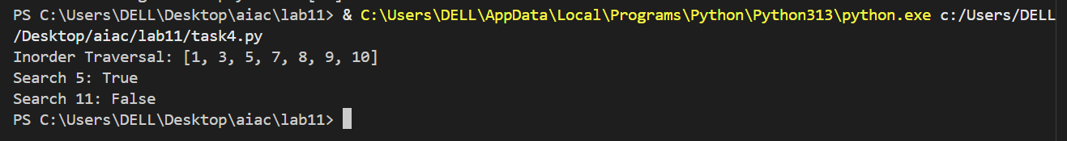

**Task 5: Graph Representation and BFS/DFS Traversal**

* **Task**: Implement a **Graph** using an adjacency list, with traversal methods BFS() and DFS().
* **Instructions**:
  + Start with an adjacency list dictionary.
  + Ask AI to generate BFS and DFS implementations with inline comments.
  + Compare recursive vs iterative DFS if suggested by AI.
* **Expected Output**:
  + A graph implementation with BFS and DFS traversal methods, with AI-generated comments explaining traversal steps.

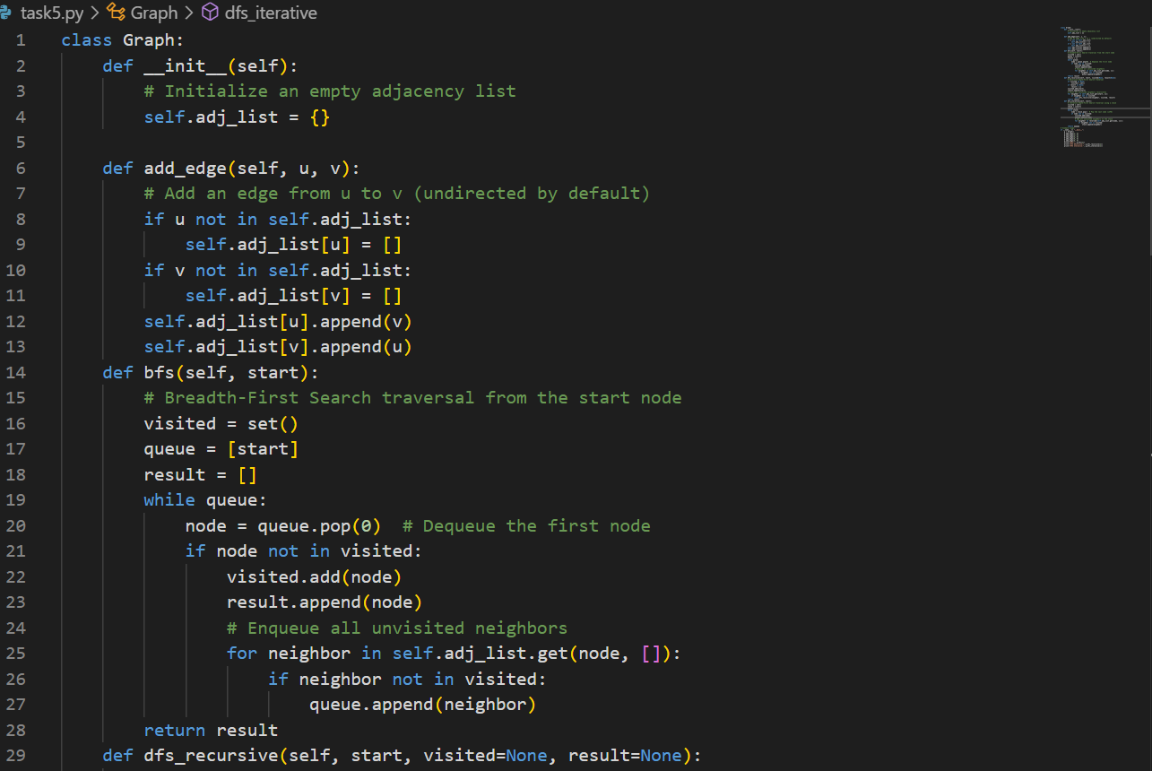

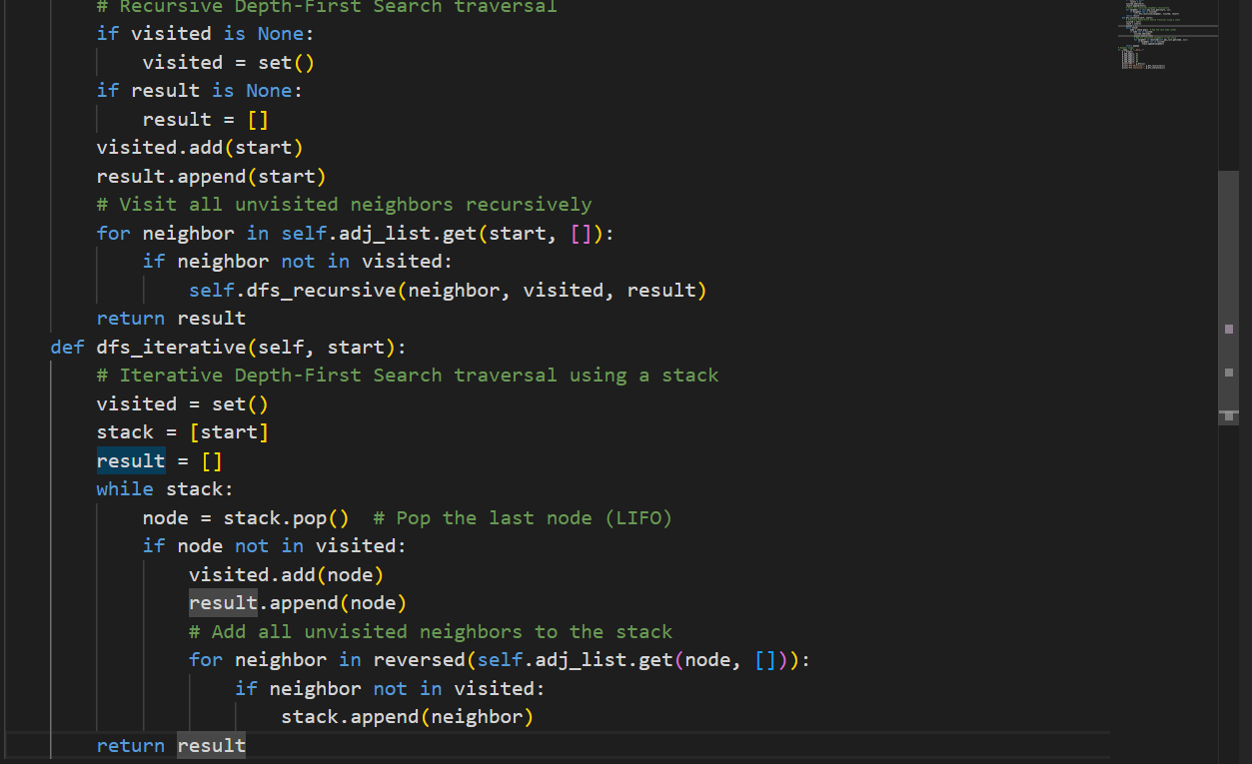

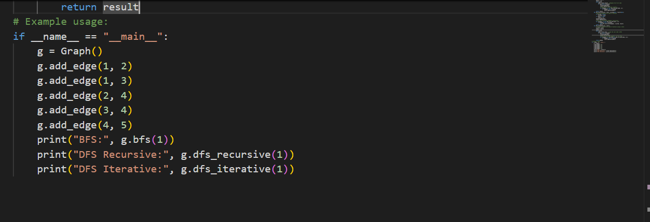

Output:

